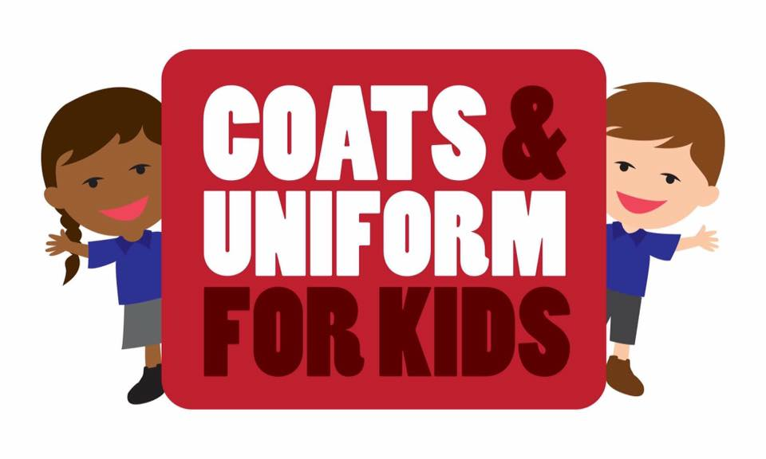

WHAT IS IT? A project that allows people who need it, to swap or collect good quality recycled Coats and Uniforms for their children. Free to those in need although if people can afford it a small donation is appreciated. Donations will be used to buy items (like shoes) that are not available to swap or collect.
HOW TO DONATE COATS AND UNIFORMS: We have collection points across the city in all libraries (except Withdean and Hollingdean) and at One Church in Gloucester Place. We can arrange for collections if you are unable to drop off at these venues. (Please email us on bhcoatsforkids@gmail.com if you need a collection)
HOW TO GAIN ACCESS TO COATS AND UNIFORMS: We run a Community Wardrobe once a term where you can pop in and select what you need. The next Community Wardrobe is on 25 November between 10 and 3 at One Church, Gloucester Place, Brighton.
AGENCY REFERRALS: If you are working for the City or a voluntary sector organisation and you need coats or uniforms for children then please contact us by email and we can arrange to try and fulfil your requirements outside of the Community Wardrobe times.
IF YOU CAN’T WAIT FOR THE COMMUNITY WARDROBE: We are a small band of volunteers but if you have an urgent need please do contact us and we can see if we can accommodate your needs
DONATIONS OF MONEY: If you would like to support this project but have no coats or uniforms to donate then please think about donating some cash. We will use this to buy items of uniform or shoes that we are unable to fulfil from the Community Wardrobe. We use My Donate and have an account in partnership with CHOMP. https://mydonate.bt.com/fundraisers/coats4kids
VOLUNTEERING: We welcome volunteers to undertake a variety of tasks including collection and deliveries; sorting coats and uniforms or helping out at the community wardrobe. If interested please email us.
Email us at bhcoatsforkids@gmail.com
https://www.facebook.com/groups/1126400404127366/
http://coatsforkidssussex.wordpress.com/
http://www.twitter.com/bhcoatsforkids

